AWS MQ
AWS MQ is a managed message broker service that makes it easy to set up and operate message brokers in the cloud.¹ It is specifically designed for users who want to move existing applications to AWS without rewriting their messaging code.²
+1
While services like SQS and SNS are "cloud-native" and use proprietary AWS APIs, Amazon MQ supports industry-standard protocols and engines like Apache ActiveMQ and RabbitMQ.³

Key Features
- Supported Engines: Currently supports Apache ActiveMQ and RabbitMQ.⁴
- Standard Protocols: Works with common messaging protocols including AMQP, STOMP, MQTT, OpenWire, and WebSocket.⁵
- Managed Service: AWS handles the "heavy lifting," including provisioning, setup, software patching, and failure detection/recovery.⁶
- High Availability: You can deploy brokers in Active/Standby modes across multiple Availability Zones to ensure your messaging system stays online if one zone fails.⁷
- Security: Integrated with AWS IAM for access control and provides encryption of messages both at rest and in transit.⁸

When to Use AWS MQ vs. SQS/SNS
Feature | AWS MQ | Amazon SQS / SNS
Best For | Migrating existing apps. | Building new cloud-native apps.
Protocols | Industry standards (JMS, AMQP, MQTT). | Proprietary AWS APIs.
Scaling | Vertical (changing instance sizes). | Horizontal (nearly unlimited scaling).
Management | You manage the broker configuration. | AWS manages everything (fully serverless).
Latency | Low, consistent latency. | Highly variable based on throughput.

In simple terms, AWS MQ is like a Post Office for your computer programs. It acts as a "middleman" that takes messages from one application and delivers them to another.
The primary reason people use it is to connect different systems that don't speak the same language or aren't always online at the same time.

A Simple Real-World Example
Imagine you run a popular Pizza Delivery Website.
- The Website (Producer): A customer places an order. The website sends a "New Order" message to the AWS MQ Broker.
- The Broker (Post Office): AWS MQ holds that order message safely in a "Queue" (a digital line).
- The Kitchen App (Consumer): The kitchen has a separate screen that "checks the mail." It pulls the next order message from the queue and starts cooking.
Why is this helpful?
- If the Kitchen App crashes: The orders aren't lost! They stay safe inside AWS MQ until the kitchen screen is fixed and turned back on.
- During a Rush: If 100 people order at once, the website doesn't crash waiting for the kitchen to confirm. It just drops the 100 messages into the queue and keeps working.

Key Concepts Explained Simply
- Broker: The server that runs the "Post Office" software.
- Queue: A line where messages wait to be processed one by one (Point-to-Point).
- Topic: Like a "Newsletter." One message is sent to the topic, and everyone "subscribed" to it gets a copy (Broadcast).
AWS MQ vs. SQS (The Main Competitor)
You might hear about Amazon SQS. Think of it this way:
- SQS is a "Modern, Cloud-Only" tool. If you are building a brand-new app, use SQS.
- AWS MQ is a "Classic" tool. It supports older, standard protocols (like RabbitMQ or ActiveMQ). If you already have an old app and want to move it to the cloud without rewriting all the code, you use AWS MQ.

Summary Table
Component | What it does | Example
Producer | Sends the message | The customer's mobile app
Message | The data being sent | "One Large Pepperoni Pizza"
Broker | Manages the traffic | AWS MQ
Consumer | Receives the message | The oven's tablet display

Task Title
Create and Verify Amazon MQ Broker
Objective
Provision an Amazon MQ broker (ActiveMQ or RabbitMQ) with default settings and validate its availability by accessing the broker endpoint link provided in the AWS Console.
Step-by-Step Process
Create the Amazon MQ Broker (Console)
- Go to Amazon MQ in the AWS Console.
- Click Create broker.
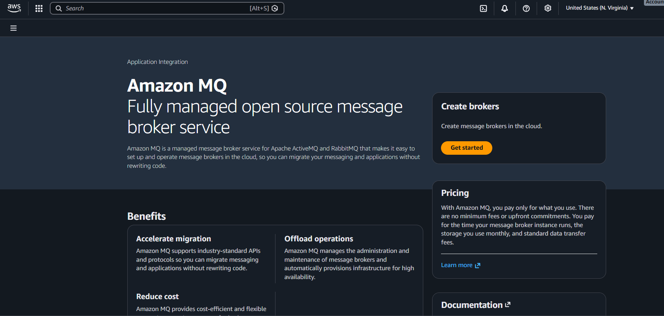
Choose Broker engine: ActiveMQ or RabbitMQ.
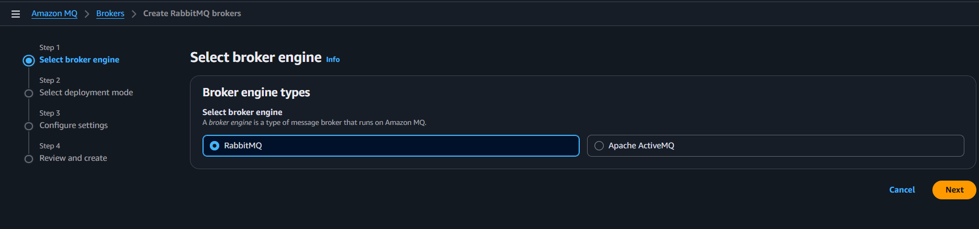

Select Deployment mode: Single-instance (dev/test) or Multi-AZ (production).
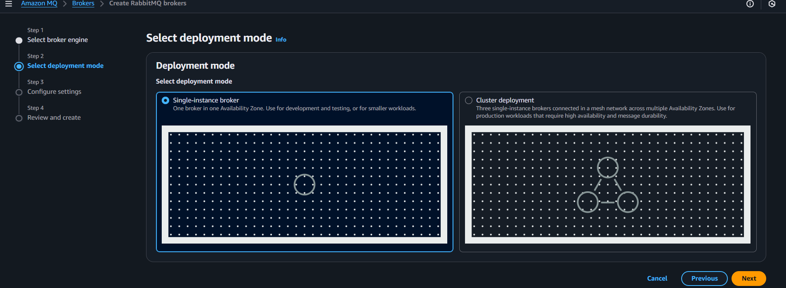
Configure:
- Broker name
- Instance type (default mq.t3.micro for dev)
- Storage (default)
- Authentication: Create a username/password for broker access
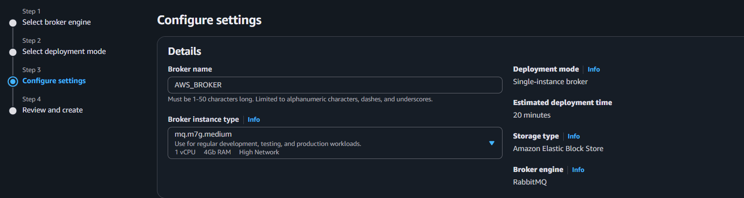
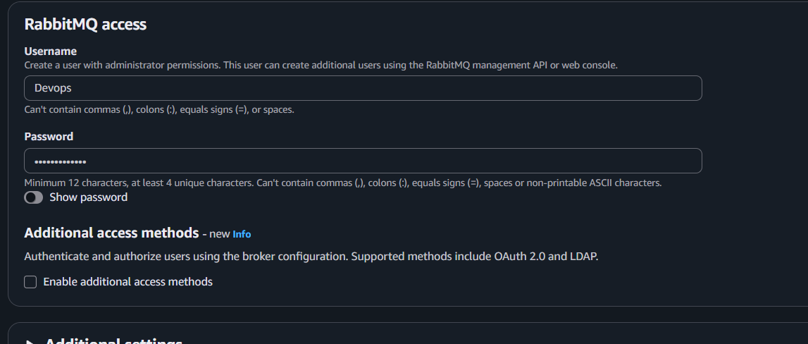
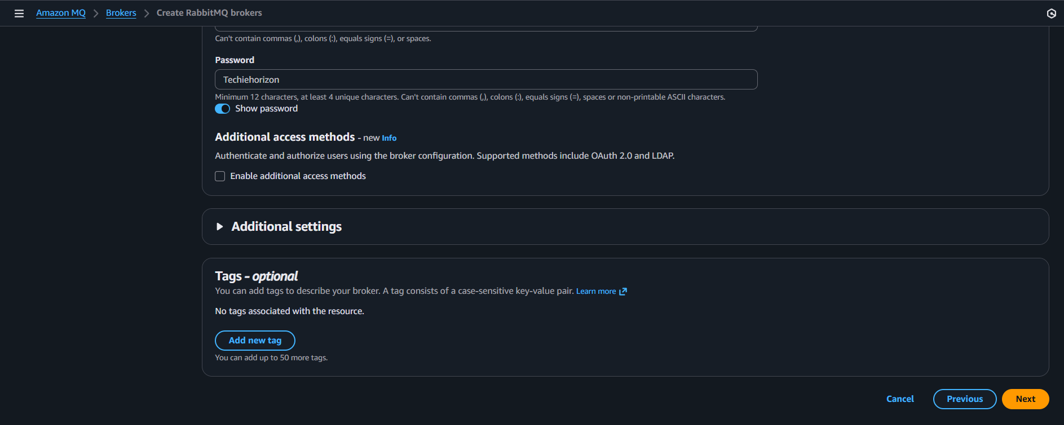
Review the details and create
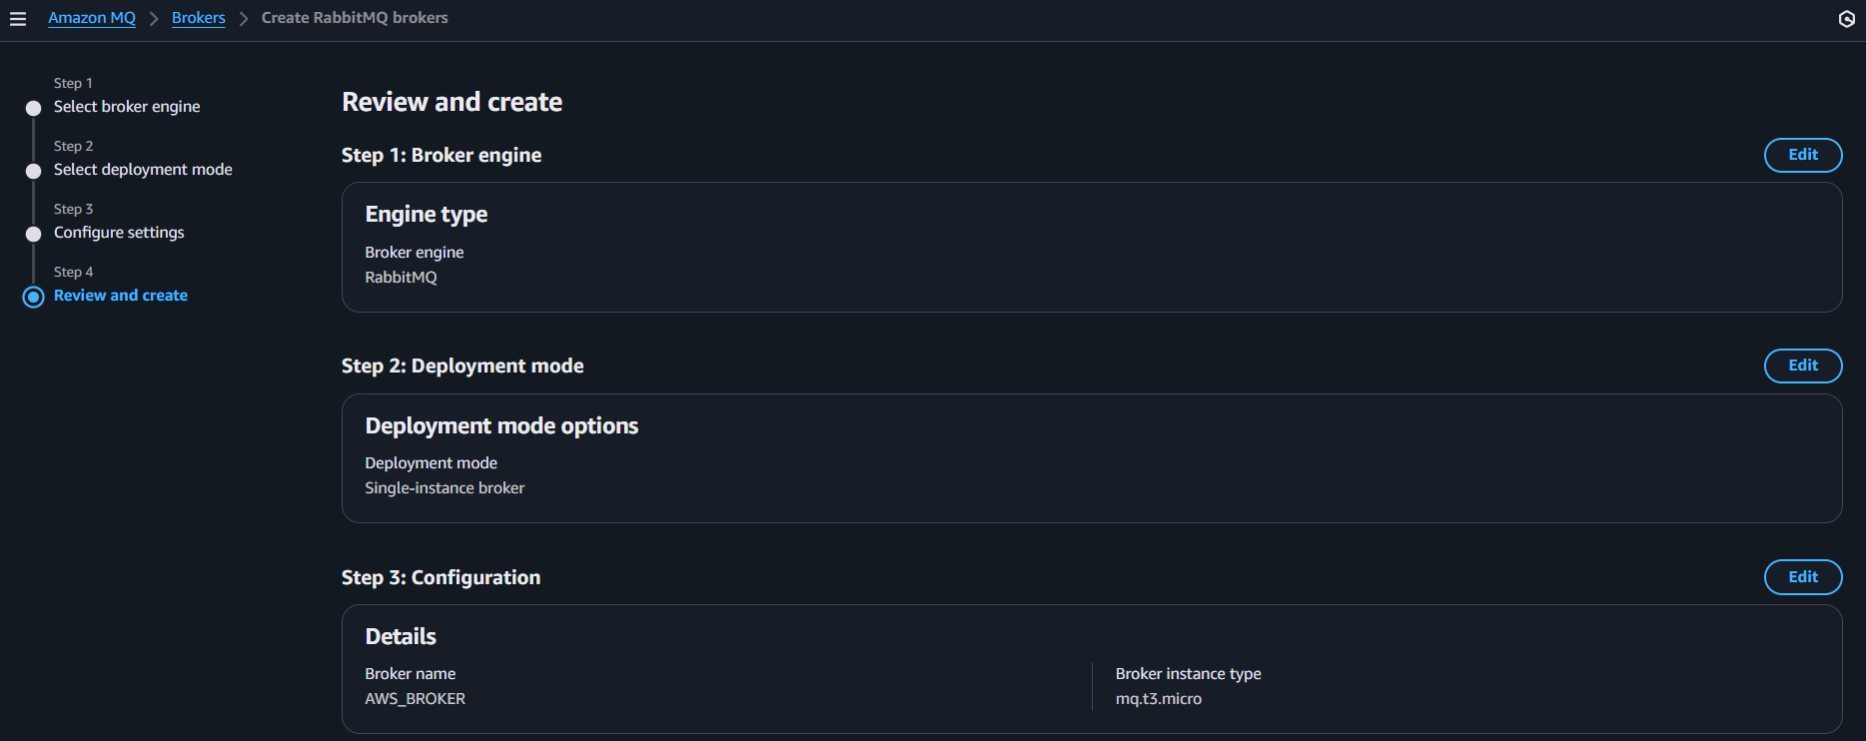
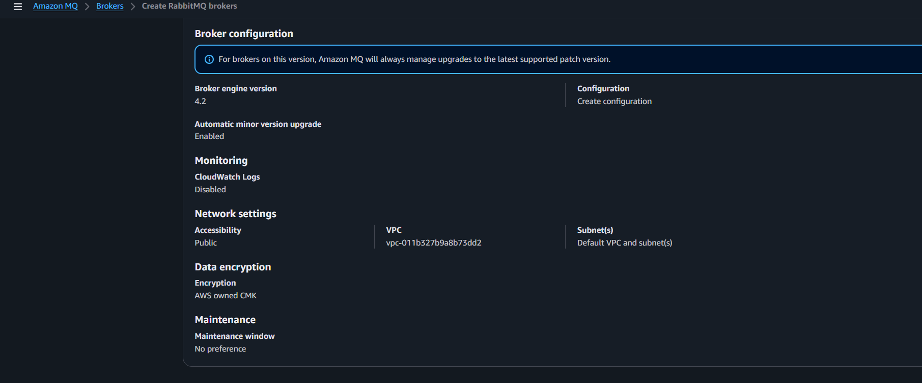

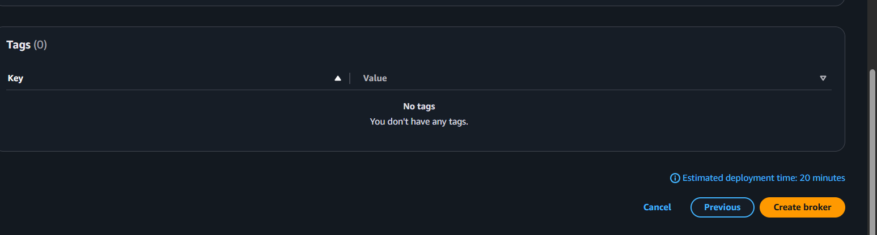
The service has been created
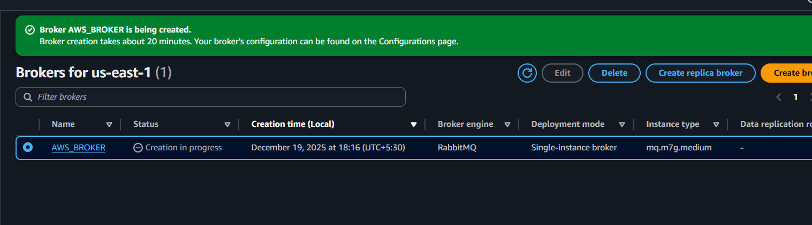
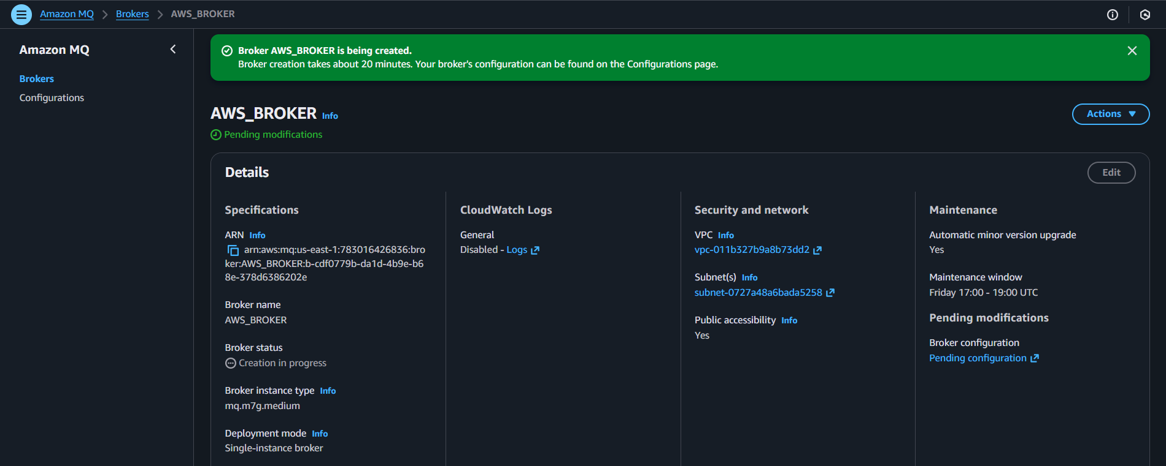
After 20 minutes the broker status will be changed then we can verify using the link,

We can check the configuration details by click on configurations and its history also
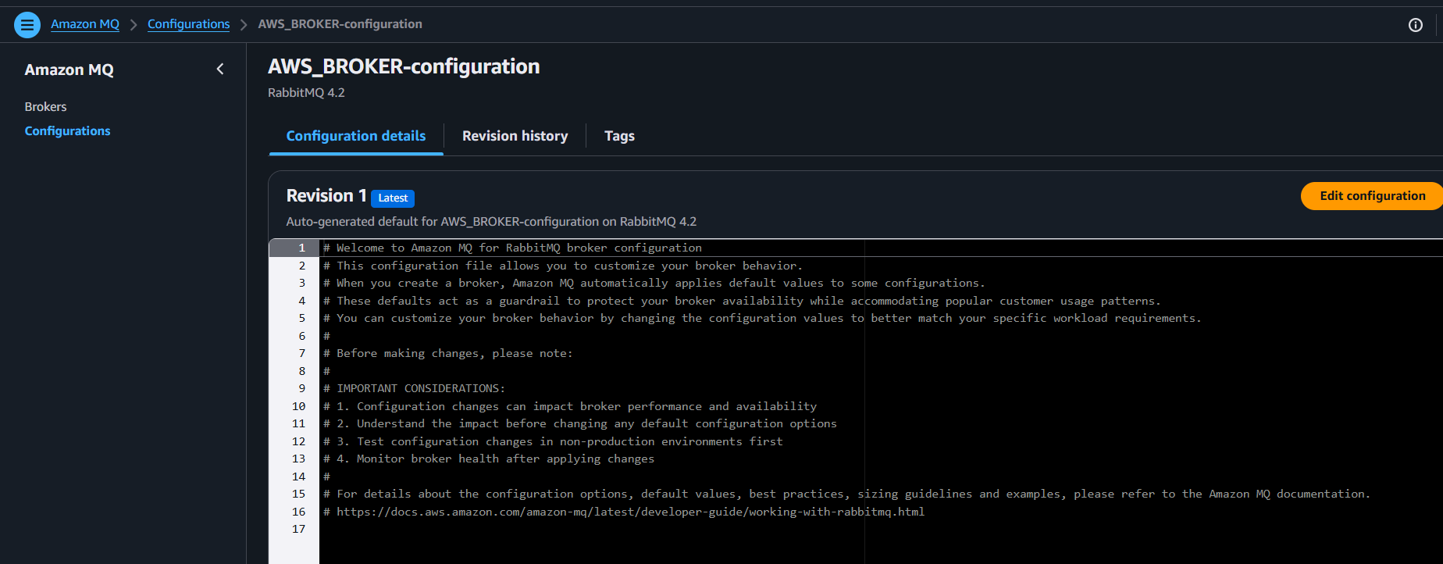
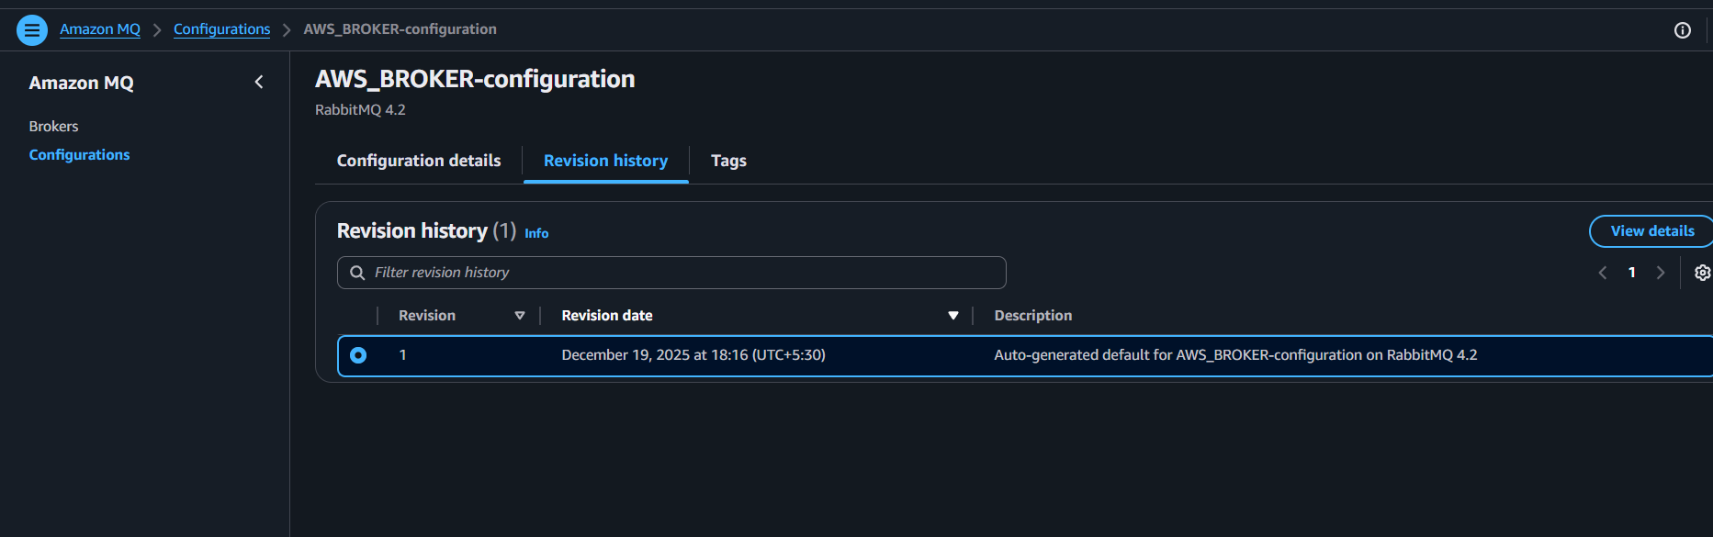
After sometime the status changed and now it running
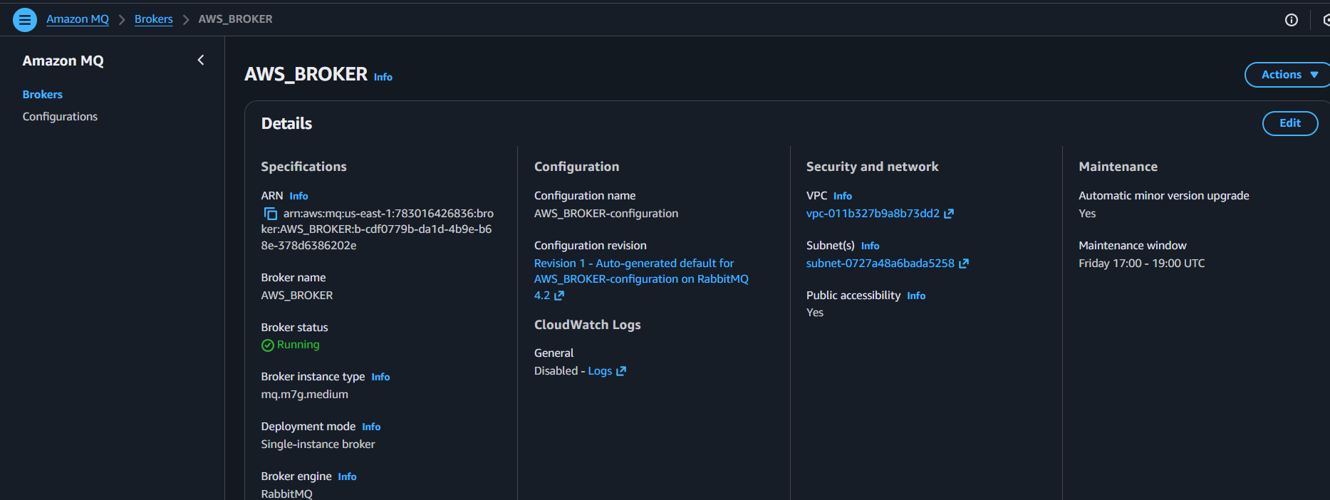
Lets verify
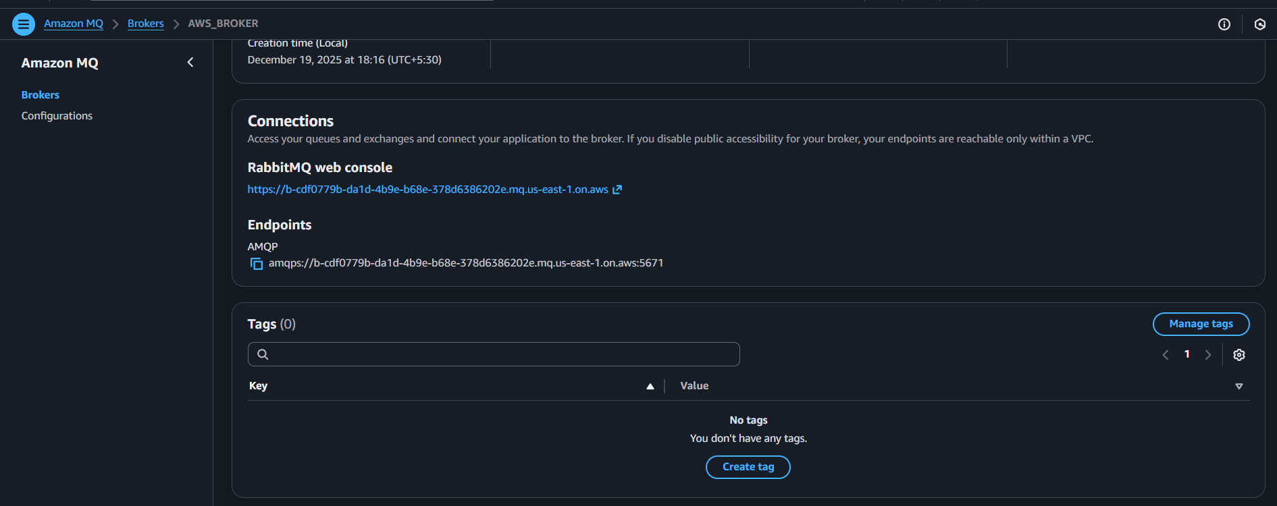
We need to provide username and password to login
The same which we provided while provisioning MQ
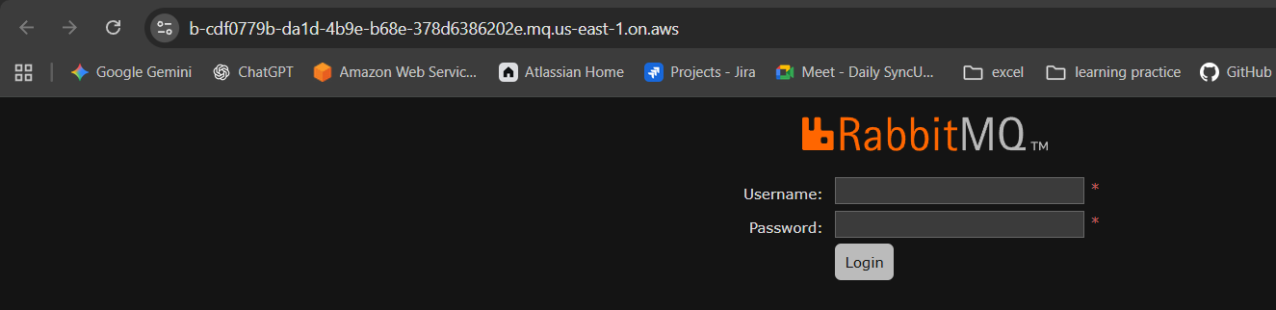
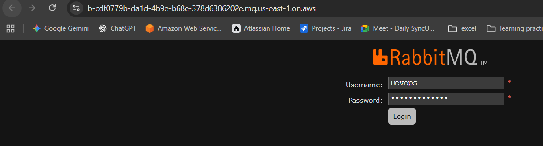
.

The overview tells that everything about storage, memory etc
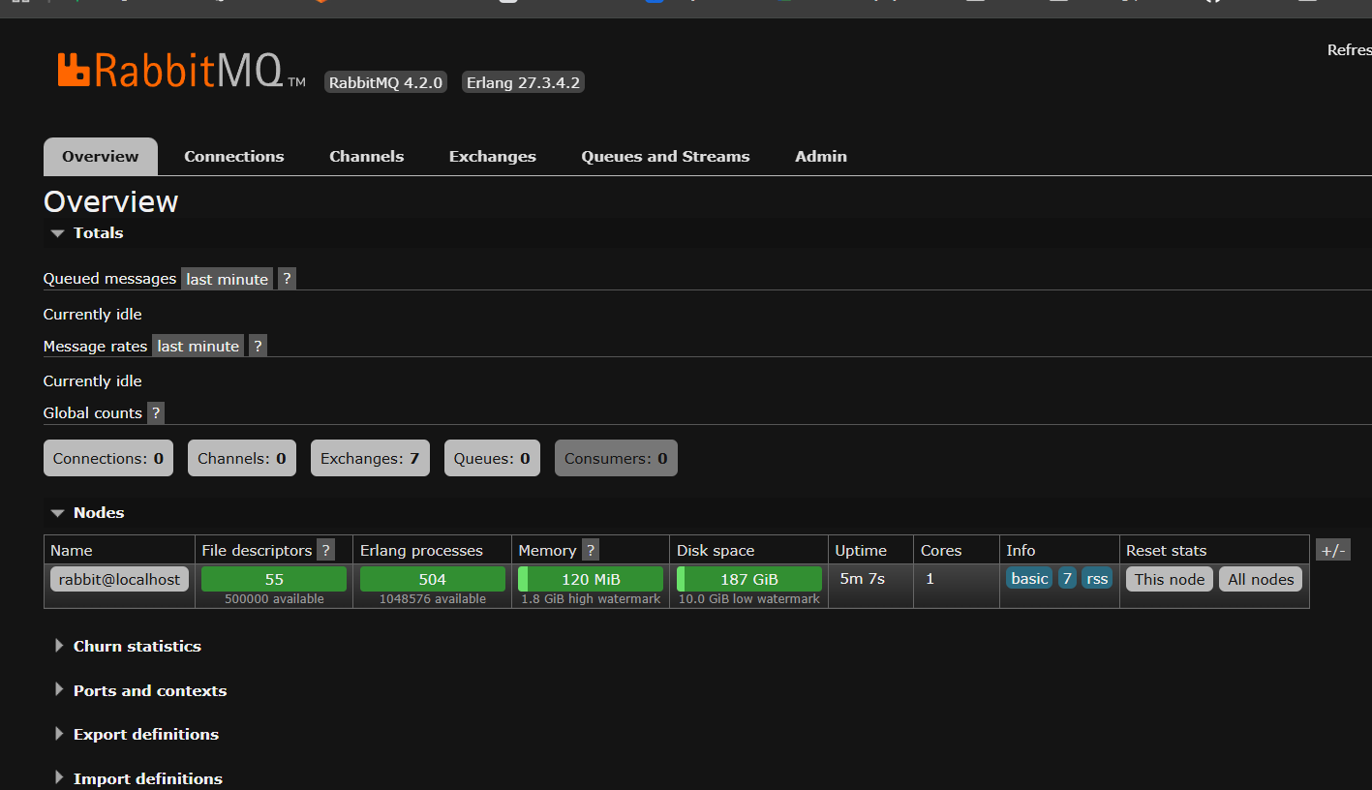
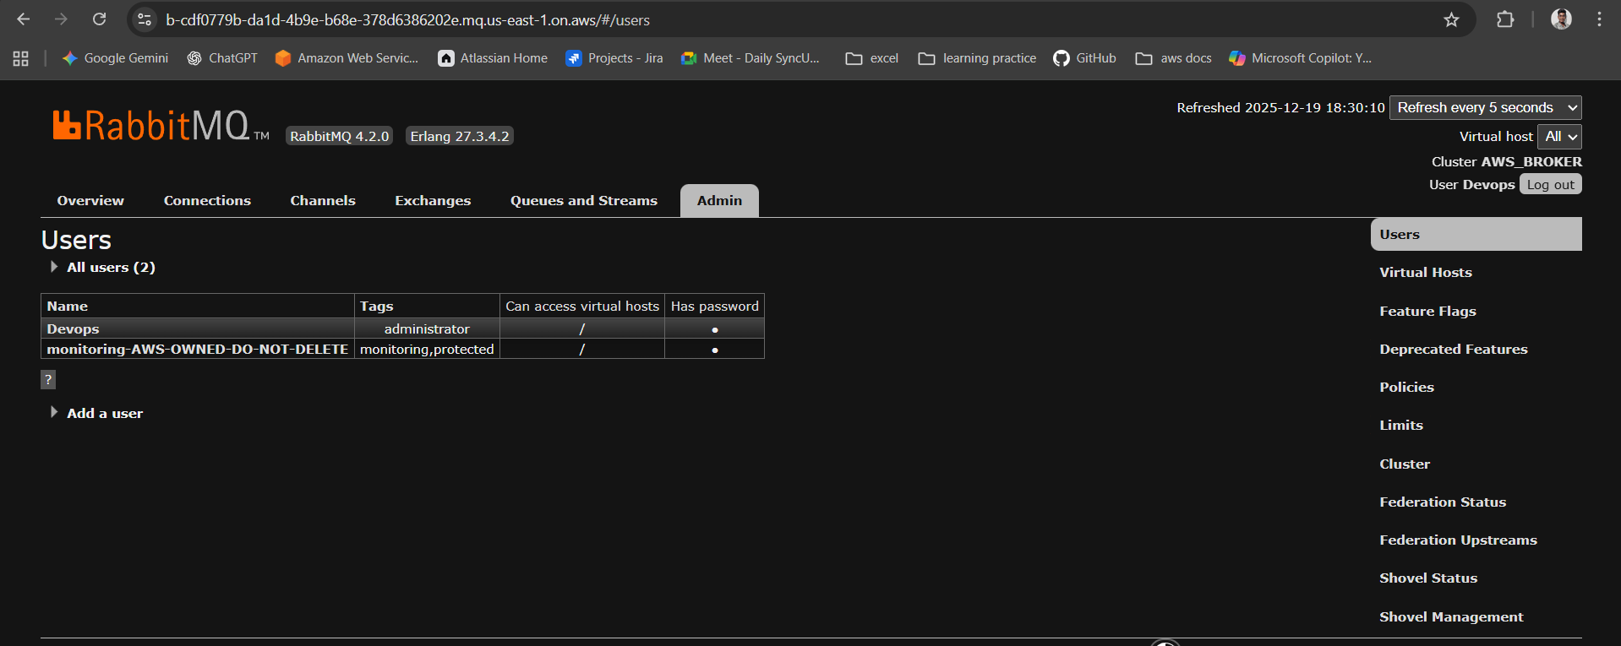
Conclusion
The Amazon MQ broker was successfully initiated without attaching any IAM role or EC2 instance. Verification will be performed directly through the broker’s connection URL in the console, confirming that the broker is active and accessible.

